|  |  |  |  |  |  |  |
| --- | --- | --- | --- | --- | --- | --- |
|  | | | **School of Creative and Digital Industries** | | | |
| **Module Title:** | Project | | | **Module Code:** | CO699 | |
| **Assignment No/Title:** | CW1 |  | | **Assessment Weighting:** | CW1 | 10% |
| CW2 |  | | CW2 | 20% |
| CW3 |  | | CW3 | 60% |
| **Submission Date:** | CW1 | 10/11/22 | | **Feedback Date:** | + 3 Weeks | |
| CW2 | 12/01/23 | |
| CW3 | 27/04/23 | |
| **M****odule Tutor:** | Justin Luker | | | **Degree:** | Degree | |
| **Student ID:** | **21905318** | | | **Student Name:** | **Amir Mohamed** | |
| **1st Supervisor:** | **Rafid Al-Khannak** | | | **2nd Supervisor:** | **Mike Everett** | |
| **Course:** | BSc. (Hons) Software Engineering | | | | | |
| **Word Count:** | **13.891** | | | | | |

# PDF VERSION/GITHUB LINK

<https://github.com/Amir94Mohamed/Main-Project-CO699/blob/main/CO699%20CW3%20Amir%20Mohamed%2021905318.pdf>

Display of the artifact

<https://drive.google.com/file/d/1enMJhQsZ0lsuS_f1EnpBQauFrJd30IJ1/view?usp=share_link>

# Project Title (Approx. 50 Words):

**A Digital assistant developed using tools such as visual studio that can contain all your Daily Tasks, Routines, Appointments, Checklists, Financial Budgeting to assist users with their daily struggles of organization and increase their work rate by ensuring an organized app that can be used like an assistant for the user’s organizational needs.**

## Acknowledgments (Approx. 50 Words):

During this project I have used various resources to aid me with the progression of the project. Researching apps related to my project like Calendar, Reminder, notes, and budgeting tools that have been released to public use and have ratings available online. My Main Primary feedback was given from my colleges and tutors which helped me a lot in figuring out the design and the requirements and their improvements. My secondary research was manly YouTube videos to see examples and methods of development in addition to some tips and tricks article by V. Gavriluk (Feb 22,2023) “10 Figma tips and Tricks” It Contains basic tips that help me begin the development of my project.

## Abstract (Approx. 150 Words):

This is to summarise the final report in a brief format, Describing the method used and its final product it produced. The method I used to develop this project was agile because it allowed the repetitive testing that helped the development process. That testing allows me to produce my projects prototype called the digital assistant, an app that could help you with your day-to-day organization of tasks. Using figma a prototyping tool that allows users to design and prototype their projects with ease. During the development process there was many obstacles that caused the project delays or issues but still managed to produce a semi functioning prototype to display the project ideas concept.

### Table of Contents (Unlimited Words):

Project Title (Approx. 50 Words): 2

Acknowledgments (Approx. 50 Words): 3

Abstract (Approx. 150 Words): 3

Introduction (Approx. 250 Words): 5

Background (Approx.200 Words): 6

Rationale (Approx. 200 Words): 7

Ethical Considerations (Approx. 200 Words) 8

Aim (Approx. 50 Words): 9

Objectives (Approx. 150 Words): 10

Risks (Approx. 250 Words): 11

Literature Survey (Approx. 1550 Words): 13

Methodology (Approx. 850 Words): 14

Requirements (Approx. 850 Words): 17

Design (Approx. 1500 Words): 19

Development (Approx. 1500 Words): 24

Testing (Approx. 850 Words): 28

Implementation (Approx. 850 Words): 39

Conclusions (Approx. 300 Words): 40

Recommendations for Further Work (Approx. 200 Words): 41

Software Artefact Download 42

Glossary (Unlimited Words): 43

References (Unlimited Words): 44

Bibliography (Unlimited Words): 46

Appendix A: Project Plan (Unlimited Words): 47

Appendix B: Ethics Checklist (Unlimited Words): 48

Appendix C: Participant Consent Form (Unlimited Words): 51

Other Appendixes (D, E, F etc. as required) (Unlimited Words): 54

## Introduction (Approx. 250 Words):

The general problem some people come across is staying organized. Keeping track of what needs to be done can be very difficult specially when there is multiple deadlines or tasks to complete. After some research into applications or tools that can assist users by providing organizational features and I have come across a blog written by Ilic, Aleksandar (2016) “Problems keeping up? 10 apps to make you highly organized”. It mentions 10 different apps that have different purposes and features the user can benefit off. The main two apps that caught my attention was app 3 “Toggl - A time tracking app that helps time management” and app 7 “Wunderlist -A to do list app that has additional features to comment/remind users of a task”. Those two apps had a similar concept of my idea but was split into different apps. The main purpose of my app idea is to provide a simple and reliable app that provides users with an organized platform to assist them with their day-to-day tasks. The features my idea will provide are based on apps users may need due to the features they provide. The features included in my idea would be the ability to time manage using a calendar/planner, create reminders for task or deadlines, create a to do list for house chores/shopping or checklist for a routine you want to make/keep, in addition to financial budgeting. These are the essential day to day apps users use that can help their organization significantly specially if they are in one application. An article by Herbert, J. (2021) “5 surprising benefits of being organized” It mentions 5 different points of how having an organized lifestyle can help improve your work rate and produce better outcomes due to less stress. The reason I want to develop this app is because I couldn’t find apps that was sufficient to help with organization of tasks/deadlines and other. My main goal in this project is to develop a prototype with functioning features to be able to test. The most challenging part about this project will be the coding of the application features because I don’t have much experience in application coding to develop apps. My current skills and knowledge of application coding will improve throughout the development of this app in addition to researching features and inspecting their code. An article on a website called Fireart Studio (2022) “Topmost Popular Programming Languages for Mobile App Development” it has many different programming languages with pros and cons for each, in addition to a small summary of what it does and best used for. It also mentions the two types of applications (Native apps, Hybrid apps). My plan from this project when fully developed is to make it functional cross platform in addition to accessible to any smart mobile device. The article mentioned many different programming languages that could be used for app development and the plan for this project is to develop the prototype for IOS to start and later adjust it for the other devices after testing the prototype.

## Background (Approx.200 Words):

My idea came from my day-to-day life tasks and that I struggled to find apps to help me organize. I have always wanted an app that was like an assistant that would help the consumer have a much more organized work to life balance. I struggled to find the correct balance between working, studying and entertainment such as social media etc... My struggle was that I will spend too much time doing one thing that I forget I have other important deadlines or tasks to complete and end up having way too little time to complete the task which will cause problems or not as good of quality due to lack of time spent on the task. That is when I started looking for apps that would help users on multiple day to day life tasks and improve the life balance to ensure best productivity of the consumer. I discovered a couple apps that have similar features to my idea such as Reminder app, Calendar, and others. The main issue was that they were separate applications that served different purposes and wasn’t very interactive with the user and I believe is limited on its features. My main interest in my idea are the features I want to be included during the development of my idea. I believe my ideas aren’t unique but are an improvement on current apps that have been developed but aren’t as interactive with the user or require additional features to provide a better user experience. These features are very interesting to me because I think it will be a challenge to code them and learn to implement them with a good user interface. This project will be developed without a team or a need for a budget, however there will be a couple technical challenges, but my main technical challenge will be trying to keep up with new markets and ensuring the app is up to date with the updated tools. The target market for my application is not limited because I want to create this app to provide a platform with organizing features to provide the consumer with an app to organize their tasks and schedule to allow for the user’s best time management. This software idea will be interesting to the consumers because it provides a platform with multiple day to day features that would help the consumer with multiple management features to simplify the users stress of organization. As mentioned, there are some similar apps such as the reminders, calendar, budgeting, and other apps. I had completed some first-hand research using the Reminder, Calendar and a budgeting tool called “EMMA” and I found them useful, but I believe that an app that has the merged features of the researched apps would provide a much better user experience in addition to improving the apps’ purpose and usage by consumers. An article on a website called “Household Money Saving” by Money Saver Pete (10/10/2022) includes a full review on the Emma budgeting app which I have used to confirm some of my issues that I had with the app. The main research I gathered so far is from personally using the applications and noting down the issues I have had with them. On top of that I have made some other research on some general assistant apps and have come across an article on a website called “the muse” written by K. Smith (19/06/2020) The title is “8 Free apps that double as personal assistants” and it mentions 8 different apps that may help the user for different purposes but have limited features that would limit the user’s usage of the app. The main issues I have come across is that some apps aren’t accessible on IOS or just designed for android phones or the other way. I want my software idea to be available for IOS and android to maximize the users in addition to being able to have access to all the features that help the consumer with their day-to-day tasks.

## Rationale (Approx. 200 Words):

The aim or this project is to help users’ organization problems of their day-to-day tasks. The purpose of this project is to provide a platform where users can store their important tasks/deadlines or simple house chores that need to be done. In addition to assisting the users with their financial budgeting. The app will provide interactive features that simplify the use of the app and helps the users by allowing them to organize their important tasks. The client required an application that would assist them with their daily tasks due to struggles of keeping track of important tasks or deadlines. My final assessment for this course is to develop a software idea into a partially working prototype. The assessment was to show the entire progress of developing this idea into a prototype. Developing this software idea into a prototype will demonstrate my skills of application development. This may be challenging because it will be the first app I will be developing, and my skills and knowledge of app development will require a lot of research in addition to practice to be able to develop a functioning prototype. My work industry requirements include the development of software and coding in different languages that includes documenting the progress of a project in development. After some research I have found a website that provides job description information called “Resources for Employers” it mentions the requirements for a software engineer and this application development module has similar steps regarding the development and the documentation of the process. I believe this app idea is potentially very useful for many users. The reason I believe that is because I haven’t found a similar app with the same or similar concept of assisting the users with their daily organizational project. In the background section I mentioned a couple apps that have similar features but was in separate apps, my app idea isn’t unique but a merge and improvement on features of apps that have been created but lacked to be maintained by their developers to the current standards. Apps such as the Reminders, Calendar, Notes have been developed but are separate apps that in my opinion would be much better if created into one app that has some additional features that would maximize the users experience and increase the targeted clients. When trying to research apps like my idea it mostly directs you to an assistant device such as google or Alexa which are good for home use but not very useful when not in proximity of the device. The app I am trying to develop would be installed on the personal smart phones which is mostly with the user. The main challenge would be coding the budgeting feature into the app because the feature needs to be simple but also secure for users. My current knowledge and coding skills are very low to be able to code the feature into a functioning prototype. This part will require a lot of additional research to successfully complete it. I have found a website by Kalinin, K (2022) “How to create a personal finance app for budget planning” it has a section “top 5 budget apps for personal finances” where it includes 5 different budgeting apps that are available to download and use once subscribed to their services. My plan is to use some of them and not the most important features and the main issues form the apps to try and find a better solution for my feature development. This software idea could potentially be used by many due to the simplicity and useful features that are coded to provide day to day assistance to the users.

## Ethical Considerations (Approx. 200 Words)

When talking about ethical considerations this project is unlikely to cause any harm to users ethically or morally speaking. Taking the project assignment into consideration, the project will be a prototype with functioning features that won’t require any personal data to be included which will eliminate the risk of data breach or any other ethical considerations however we will discuss some of the ethical considerations. The main one to talk about is the data breach. Securing the data inputted by the user will be essential to the final release of this project but the prototype will focus on ensuring that the features function. Feedback gathered from the prototype will help improve the features and find out any bugs that may have happened during the development in addition to simplifying the use of the application. The application will require the users to login to gain access to their app. This is to prevent anyone being able to access other users’ data, in addition to that I plan to add a way of improving security with maybe using two factor authentication or other security methods.

## Aim (Approx. 50 Words):

The purpose of this software idea is to demonstrate my skills and knowledge that I acquired during the modules of my course and its required me to develop a functioning prototype of a client or an app idea. During this process I get to develop an application idea that may potentially be very useful to many people if developed correctly. This project will be testing my coding and implementing of application features to develop an application, in addition to documenting the progress of developing the app. The project aim is to provide a functioning prototype of my application idea that can be tested to receive feedback. This project consists of 4 main features that would be very useful to users on a day-to-day basis. This idea will provide a platform for users to organize their day-to-day task/routines in addition to financial budgeting aid. The main four would be Calendar, Reminders, Notes, Budgeting. These features would be useful for users to create an organized system for their day-to-day organizational struggles. (1st) Calendar feature would provide an overview of a calendar in addition to any schedules tasks the user has set in the coming days, which will also provide interactive features such as reminding the user a day before the scheduled task. (2nd) The notes feature would provide users with a page to create notes that can be written into checklists or shopping lists etc... The created notes for example a shopping lists can be saved and attached to either a calendar to schedule a day to do shopping or a reminder.(3rd) The reminders feature allows the user to set a reminder and schedule it in a much more specific time or way such as time of the day, dedicate duration, priority of task, and can have an attached list from notes that can consist of a quick note or checklist. Reminder’s feature can be used to create a daily checklist reminder for example to take your medication if daily medication is needed or a completely different purpose to try maintaining a daily routine. (4th) The last feature would be financial budgeting, which will allow the user to manage their finances and have an overview of their financial status. This app idea could be very useful because it could assist users with their day-to-day tasks, in addition to provide an organizational system for users to manage their tasks to ensure their productivity is maximized. I believe this app will solve many issues and have a much better impact to daily organization for people.

## Objectives (Approx. 150 Words):

**Development Objective**

1. A) Complete the app screens by creating a template. Creating the template and use template to create multiple screens for the different requirements to provide a working user interface to the working screens. Implement the different screens and assign them their requirement that will be implemented at a later stage.

(Provides a starting base for the upcoming parts)

B) Set up DATABASE/Data Storage for the data that has been inputted by the user to create or login their accounts.

After this objective has been completed the app should have a working interface with multiple screens that are linked by a navigation bar.

**Implementing the requirements**

1. Complete the coding of each feature and implement them into the correct screens that was created for each requirement.
2. Calendar Screen/ coded Features and implement into assigned screen.
3. Reminder Screen/ coded Features and implement into assigned screen
4. Notes Screen/ coded Features and implement into assigned screen
5. Budgeting Screen/ coded Features and implement into assigned screen

At this point of the development, there should be some functionality of switching between the screens using the navigation bar in addition to the different features (A, B, C, D) of the app being functional.

**Final check of requirement objectives**

1. A) Completed the coding of requirements, Final Checks of the implemented features.

B) Adjusted the interface and features to work in sync

After 3rd objective has been completed, the prototype app should be functional

**Implementing the Login/Create features.**

1. A) Complete the login/ create account interface and link to data base.

B) Create the apps first prototype and test out the features.

## Risks (Approx. 250 Words):

|  |  |  |  |  |  |  |
| --- | --- | --- | --- | --- | --- | --- |
| **Risk** | **Description of risk** | **Probability of risk occurring** | **Reason of risk potentially happening** | **Impact it will cause** | **Actions to avoid risk** | **Impact on entire project** |
| **Coding Problems** | Problems with coding the features required | Medium - high | My coding of features may cause issues when coding the features | Major delays in the project + not having a functioning prototype. | Researching into the required features + Practice coding | Failure of project / assignment.  Delay to prototype outcome |
| **Implementation problem** | Problems with implementing the feature into the app | Medium - high | My coding experience may cause the delay | Major delays in the project + not having a functioning prototype. | Researching into the required features + Practice coding | Failure of project / assignment or  Delay to prototype outcome |
| **Aggressive / missing deadlines** | Too Little time to complete an objective for multiple objectives | Low | Not enough time dedicated to project | Causes objective deadlines to be missed | Dedicated enough time for each objective to be completed & checked | Failure of project / assignment or  Delay to prototype outcome |
| **Low Productivity (low project progression)** | Working slow / low project progression | Low | Not being able to understand how to approach the objective/ Slow progress when working on project | Major delay to the project outcome | Each objective has a deadline to be achieved for and each objective has enough time dedicated for its completion | Failure of project / assignment or  Delay to prototype outcome |
| **Technical Issues** | Issues occurring with software or hardware | Medium | Technical issues may occur at any time of the development | Major delay to the project outcome | I have done some research on troubleshooting while development | Failure of project / assignment or Delay to prototype outcome |

## Literature Survey (Approx. 1550 Words):

Our current skills and knowledge of developing application software are basic and will develop with the progress of this software development. This may cause the project to be delayed throughout their development cycle but allow me to gain experience in developing software. According to an article written by Firenze, A. (2022) “14 essential App Development teams skills you must have” mentions the essential skills that an application developer requires to develop software applications. While searching for apps with similar features to my idea, I came across an article written by Ching, C. (2021) “How to make an app in 2021 from start to finish” provides a stepped guide on how to develop an application and the necessary steps to take to ensure your project will succeed. The research has allowed me to verify certain features are very useful to have into my project. The first feature included into my project is a calendar, an article by Stevens, G. (2022) “6 best calendar app features to help you manage your business better” it talks about all the useful features a calendar has that is able to help users with a variety of features that can assist one or a business. The second feature is to create reminders that can be customized to the user’s needs. The third feature is creating notes that are customizable to the user’s needs such as creating a checklist for shopping, or one to take prescribed medication regularly. The last feature would be budgeting, my research into the development of my software idea allowed me to find an article written by Shibli, A. (2022) “15 best organization apps for life & work in 2022” It mostly includes calendar and note applications that are supposed to help the user be more organized with their tasks. All the apps have similar features but was designed differently and have a different subscription fee. The main issue I have found was that the apps that help you stay organized with your day-to-day tasks are separate applications and each may possibly have a different subscription fee. Another day-to-day app users may require is financial budgeting. A review by Money Saver Pete (2022) “Emma App review” provided a clear understanding of the benefits of financial budgeting, in addition to budgeting being used by many people and potentially most of our future users. As many other apps EMMA provides more features the higher subscription you sign up for. My project is meant to be a solution to multiple problems, Firstly the issue of having multiple apps which sometimes causes disorganization. Secondly it would provide one app with multiple features that will be useful to the user’s organization troubles and mostly will allow the users to save money instead of subscribing to multiple app subscriptions. The research completed helped verify that the features will be useful to the users by providing them an organized system that is easy to use. The project plan and objectives allow the project to be divided into sections when being developed. This allows the development of the prototype to be split into sections that will function as intended if the objectives have been completed no matter what order they were coded in. A website name Altexsoft released a very informative article in 2019, “Best practices and methodologies” Contains detailed information on what project management is, in addition to how many different methods of developing with some descriptions and diagrams or the approach. There are many options to choose from but the most common ones is the waterfall model or the agile model.

## Methodology (Approx. 850 Words):

In this section I will be discussing the chosen method of developing the project idea, in addition to reference any research completed towards this project and describe my decisions. A website name Altexsoft released a very informative article (2019), “Best practices and methodologies” It contains an explanation on how the common methods such as Waterwall and agile method function and how they are used in the development process. I have also found an article on a website called “Wrike” (2021) “*The benefits & Advantages of Agile*” which contains the benefits of the agile method in addition to a comparison between other similar methods. This project will be developed using the agile approach. This is due the advantages agile methodologies provide in addition to the flexibility agile provides in term of adding additional requirements throughout the process or sudden unknown changes. This project will develop my first app prototype and my knowledge and skills of application development is very limited and requires a lot of research and coding assistance. My plan is to use an application development tool to assist me with the coding of the prototype and features. I believe staying on track with the scheduled project plan/ objectives is essential for the project outcome. Since the project management method has been chosen to be the agile method, we proceed by reminding ourselves with the project plan and objectives.

The projects plan consists of more detailed planned step by step guide to complete the prototype, where the objectives are intended as a project progression goals that provides an overview of how the project has been progressing. I have found a website by Welch, S. (2021) “the 5 best C++ IDES” which provides a bunch of tools that have pre-set IDES to help users productivity and explains what IDE is and why it’s useful. I have also found a website by Cardello, J. (2023) “14 best prototyping tools for UI/UX Designers”, it lists 14 different tools that could be used to design a user interface and potentially assist on coding the interface to have a good base to start the project on. The project plan has been split into multiple sections for each stage to split the workload and provide a better time managed plan to reduce delay risks. It also allows the development of the project to be completed in sections to complete an objective and see progression of the project. Each objective will have a stage to go over the completed work to ensure any unseen issues and double check the written code for any spell errors. My plan on how to implement the method into my project was to try to develop each objective and approach them individually using the agile method. This is because in my project plan, I have split each objective to have multiple tasks to ensure the objective was given enough time for completion. I will be using visual studio code to try to prototype my project. To assist me with coding I will be using some software development tools.

My Plan for this project is to Start the template of the mobile app screens on visual studio because it’s a known tool and my hope was that there is a lot of research available for it to start mobile app projects with my project plan, I intended to start the template for my project to begin the project development. After a while with no progress on the template due to lack of experience on mobile development using Visual Studio caused me to make some changes in tool choices. I researched for tools that aid in the design and development of mobile apps. My Experience in mobile coding is limited and was a risk I have identified in advance which is why I increased the project time plan to provide more time for the development stage. After some research I came to a choice between two known mobile app development tools known as Figma and bubble. Figma was known to be a very good development tool for especially prototyping. Bubble was very similar to figma and provided similar features. I spent about an hour on each to see which I would better prefer because that was the only relevant factor to deciding which is more suitable for this project’s progression. I Have Created A development plan to create the app with a guide. I have used a project management tool called “Monday” To help me manage the project and continue to progress. The Tool provides a professional layout to the steps that allows the developer to clearly decide their next steps to complete the project with a higher success rate.

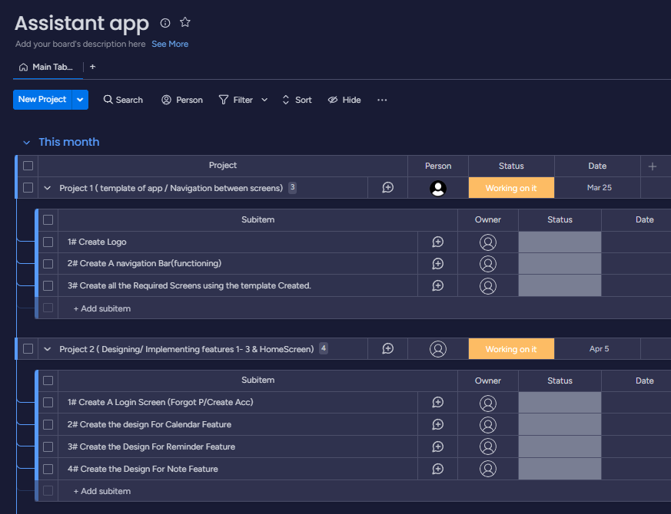

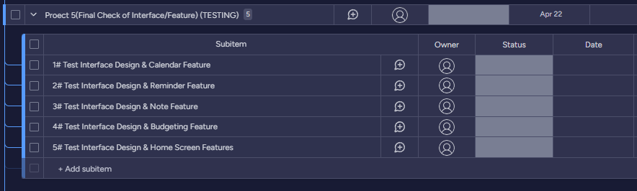

Monday is a work management tool that help me significantly by providing an excellent layout for a project plan that contains many steps. In addition to notifications on due schedule to keep a great time management. The most common method of development is the agile method because of its benefits and repetition of the steps until the project is stable enough to be released to users or client for further feedback. This was easy applicable with the tool figma. Figma provided a prototyping feature which allowed me to run the project simultaneously while developing to see how it would display and function. The agile method consists of stages like the way my project plan is planned which made things simpler to decide. In addition, with Figmas development tools this will improve the projects development. Since I have my project management tool with my project plan included and the chosen development tool, I just require further information on the features I would like to be implemented.

App Features research: -

The features included in the project aren’t unique or overcomplicated which didn’t require much research on. For the calendar, Reminder, and Notes Feature It was very straight forward and didn’t require much research however I looked at some feedback the apps received and tried to find some improvements to include to my project. The purpose of these combined features was to provide the user a much better overview of their life and assist them by providing an organizational app of their daily essential tasks. Scheduling apps seemed to be very limited and mostly monthly/weekly pay to gain proper access. For the calendar, Reminder, and Notes Features they would provide a combined app for their tasks that they can use in various ways to schedule their required tasks or their forgettable tasks. In addition to those apps people often want to have a financial aid to help them budget and keep track of their finances. This made me research into budgeting apps which is included in the rational section. But to quickly summarize I found a variety of budgeting tools that I have used to design and planned features for.

## Requirements (Approx. 850 Words):

In this section I will be discussing the requirements regarding this project. This project idea wasn’t requested by a client, this project idea came from experiencing the issue and wanting to find a solution for it. The issue was that I struggled to find the correct organizational system to keep my balance between studying, work, and socializing. In addition to that I had couple people with similar issues throughout their day-to-day lifestyles. I was able to have a short interview with potential users that helped me set a couple of set requirements the project needs to include. The interviews were short but helped understand the issue better and help improve on the requirements. Each feature helps the users stay organized,

* Calendar will need to be able to schedule some event or task with some customization of how and when to notify.
* Reminders will need the ability to schedule a task in a much more specific way such as time, days etc...
* Notes need to allow the ability to write notes in addition to customize the note into a checklist to use for a daily routine checklist
* Budgeting needs to allow users to manage their finances using tools provided.

The requirements aren’t complicated due to the apps purpose, and I will try to keep the application simple for users to use. The discussion about the security of the app and accessibility was very informative, It showed that some people don’t require lot of security to keep track of their tasks. This made the 4 digit pin a customizable feature for the people that want to enable it. The accessibility conversation was different because the initial plan is to allow access to al smart devices but at final release this includes to any other smart devices such as smart watches.

**Functional: -**

1. Calendar: Schedule events + have an attached note from notes feature.
2. Reminders: create more specified reminder (specific time/Day) in addition to creating a daily reminder of a checklist using notes attachments.
3. Notes: Allows to write notes + create checklists, attachable to reminders and calendar.
4. Budgeting: provides the ability and tool to financial management and have an overview of your financial savings.
5. Security: adding login & password with the possibility of additional authentication required for new devices. (Unlocks app with FaceID or a set 4-digit code)

**Non-Functional: -**

* Simple & Fast interface
* Interactive with user

**Questions asked during the short interview:**

1. **What is your main way of staying organized (keeping track of what you need to get done?)?**

1st, Currently I don’t have one I just write down a note of my what I need to do and try to get my work done that way, its very troubling because I miss a lot and I am very unproductive.

2nd, Calendar but its not very interactive with me and lacks the necessary features, tried to look for some other app to help with staying organized but they either cost monthly and are limited on the features.

3rd, I have non and it’s causing me a lot of trouble at work and home, I am constantly late to deadlines and miss important points and my home is a constant mess.

1. **Do you use any app to stay organized?**

1st, I tried to look for an app to help me with organizing but the ones I found they are limited on features and server singular purposes.

2nd, Calendar was supposed to help me, but it hasn’t been working well. I do use a medical app to remind me to take my medication that I need to take daily and some multiple times a day.

3rd, I have tired an app that is supposed to help you maintain a daily routine, it wasn’t much just an app that had a checklist of things you want to do such as walk, shower, brush teeth etc. but it also had subscriptions to unlock further features.

1. **If you pay for subscriptions how much total does it cost, you to try stay organized?**

1st, at one point I had a couple subscriptions to different apps that supposed to help me stay organized and even budgeting apps that ended up costing me 50£ and it still didn’t help my struggles of horrible organization.

2nd, I have a budgeting app that cost 10£ a month to maintain but it is very slow and not very useful. I didn’t try apps to organize my tasks

3rd, I have an app that I can also access on my laptop and see, its very confusing to understand and try to utilize on a daily basis. The app allows you to create a weekly schedule that help you stay productive any maintain a balance between socializing and working.

1. **Do you think an app for daily organization could be useful?**

1st, most definitely, if its dedicated to helping someone keeping track of their necessary task on a daily would be very useful.

2nd, Of course, any app that could help me keep track of my tasks from house chores to university deadlines would be useful

3rd, 100%, keeping track of your daily tasks is essential.

1. **What would you need to help you stay organized in your day-to-day tasks or in general?**

1st, I think there aren’t many things you would need. But a calendar, notes and maybe reminders would be needed to keep track of what needs to be done.

2nd, an app that allows me to write down a task as soon as I get it and it should provide the ability of reminding or adding notes to the reminder.

3rd, An app that help me maintain my task from work deadlines to home chores such as laundry, in addition to financial budgeting.

1. **What is wrong with the current developed apps?**

1st, They are alright but don’t seem to help me stay organized, and some are overpriced for how little they do.

2nd, they are alright but some serves a purpose like mine but won’t help me and owning multiple subscriptions is getting expensive.

3rd, They are good for their designed purpose but they aren’t designed to serve as a day-to-day tool for organization or assistance to the user.

Another discussion with the three people I had a short interview with, and we discussed the security of the app and accessibility. We argued whether a 4-digit pin was required to access the app and if the app would be accessible to other devices that are also smart devices.

## Design (Approx. 1500 Words):

In this section I will be displaying the designed wireframes of my project and try to explain the designs. I will try to explain how I plan to implement my method into the project development. I will be using the agile method for each objective separately. This will allow me to focus more on the stage I am currently developing and will show a better progression in addition reduce the risk of delay or low productivity identified in the risk section. The project plan is split into many sections with each having subsections and completing a sections subsection is equivalent to completing a goal set. The objectives are the goals set and will provide a clearer overview of the project progress.

**Login: -**

This is the login screen, comes once to the user when first downloading the app. Allows the user to login if they have an account or sign up for an account.

This is to ensure the users information isn’t public and secured for the users use only. When creating the account the user sets a 4 digit pin, this pin will be used to regain access to the account. This pin will be used at any time users launch their app to provide some sort of additional security to the clients data.

A welcome message with potentially a small app description or introduction.

**Profile: -**

This would be the profile screen, because the app isn’t based about the person’s profile it doesn’t need much user information apart from name and the email address used to sign up with the option to add a picture.

Here is also where the application settings are. Settings that a user would like to customize themselves. For example, Dark / Light mode is a setting many users may enjoy but not all do.

The purpose of the app is to assist with organization; therefore, the security of this app is based on the individual users. The security settings include: -

Enable/Disable 4-digit pin / Even If disabled. Pin still required for finance screen

Enable/disable FaceID/ TouchID

**Home Screen: -**

This is the main screen when the app is launched and granted access. Includes the app name and profile access at the top.

The “Today’s Schedule” section is where any planned events or set reminders are found listed from the earlies first to the latest last.

First click on “Today’s Schedule” enlarges the section to cover entire screen and enlarge the schedule board.

“Set New Reminder” & “Add Event to Calendar” Allows users to create a new Reminder or add an event to the calendar.

Provides navigation to other features/screens.

When the schedule board is enlarged or adding to the schedule will make the Gray box at the bottom of the screen turns into a “Return” button.

Reminder: shortcut to create a quick reminder

Calendar: shortcut to schedule an event.

Calendar: -

This is the calendar screen.

Events holds the scheduled events and lists them from earliest first to latest last.

Calendar navigation allows users to select the month and potentially year with a simple drop-down menu to change year and arrows to change between months.

Monthly calendar shows the days in the calendar, and it is colour coded from red to show a busy day, yellow/orange medium and green for free day.

When clicking on a day in the monthly calendar it displays the pop up to schedule an event if required.

Navigation bar: to switch between the screens/features available.

Reminders: -

This is the Reminders wireframe. The top provides the current date and next to it the ability to add a new reminder.

The list of reminders lists the set-up reminders and lists them earliest first and latest last to keep it organized.

This will show the selected reminders details any description time and name or the reminder. Trying to set up a new reminder will also display the details requested to notify the user.

Navigation bar: to navigate through the app

Notes: -

The top is same as most screens containing the screen, you’re on and the current date with the option to create a new note.

Saves the notes written by the user and displays the last 3-5 opened. Clicking on it will enlarge it to full screen for better viewing.

Shows a preview of the selected note or opens new note when trying to create a new note. Holding down in the notes box will maximize it and show a minimize button in the corner.

Navigation bar.

Finance: -

Finance screen is the budgeting feature. The main screen is the first look you will see when clicking on it. It allows users to have an overview of their total income, in addition to overviewing how much they have dedicated to the save spaces.

Dark grey boxes labelled for their individual save space. Shows the total dedicated for their purpose. Clicking on a box will show the entire history for each month.

The management screen you can access when clicking on total bills which will also show you your previous months.

Allows you to type total income.

Allows you to set an amount of money and dedicate it to a save space* The “drop down list” will allow you to select from your save spaces to save money there. Confirm button to confirm the transaction.

*Save spaces for money management.

## Development (Approx. 1500 Words):

The first two steps of the project plan were to “Use the researched gathered to double check the language to code the software idea in and the correct tool is selected” & “Start creating the template of the application screens”. Figma was the selected tool for the development in addition to the screen template being almost completed while testing the tool. Completing the template wasn’t difficult because it just required to make a navigation bar and the logo in the top corner. The logo is something I designed while on a break and decided to use for my logo. The navigation bar wasn’t difficult because there were many tutorials on how to create a navigation bar on YouTube that where very helpful.

With the first two steps completed that meant I have a project tool chosen for development in addition to have a completed Mobile App Template including a navigation bar and a logo. I was able to proceed to the next stage which was to create a login screen that includes a forgot password and create account link. In addition to the starting screens for the Features and home Screen.

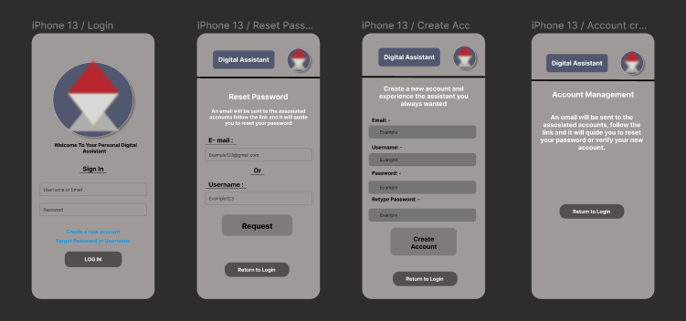

These are the designs for the login with will later have some limited functionality. Also, The Main Screen templates with navigation bar, Screen title and logo.

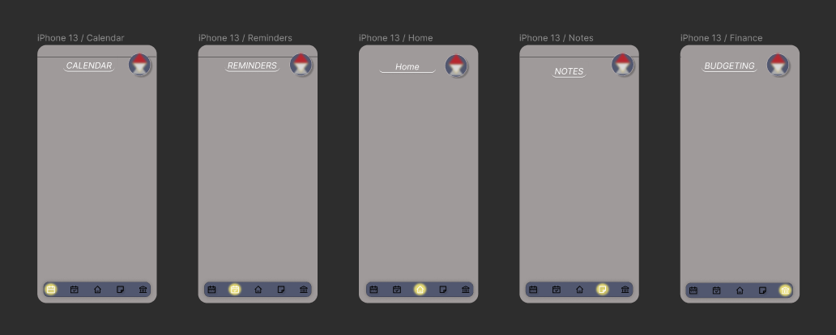

That was the first project stage completed. Including the first subsection of stage 2 of the project. Stage two of the project was to design the projects main screens and wit the help of my previous designed wireframes I had an idea of how to design the main project Screens. The tool I have been using is called figma and the way you design is like wireframes, but it adds a lot of customization capabilities that make it look much better. 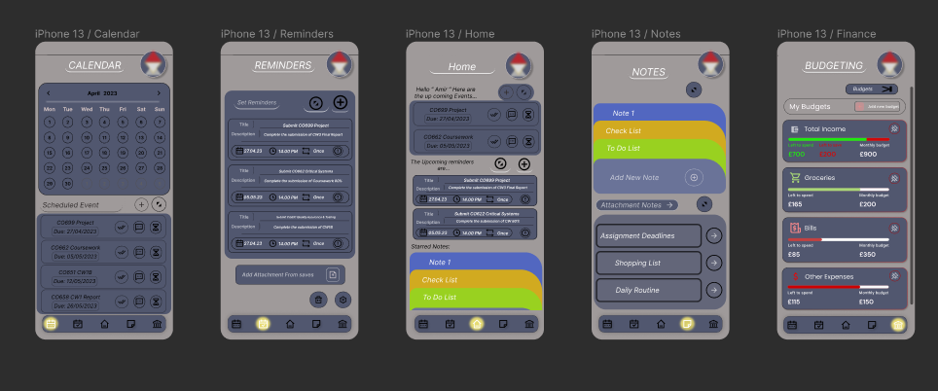

These are the Completed designs of the project’s main screens without the budgeting screen and mark the completion of the second stage of the project plan. These have no function currently but will receive individual implementation in the next stage. Starting with the calendar first reminders second and notes thirdly and budgeting lastly. The home screen will contain a combination of miniatures from each feature.

Starting stage 3 of the project plan will be the implementation of the individual features apart from the budgeting which I thought would need more time.

Calendar: - I started with creating a calendar widget and components that I would require to create the calendar feature. Figma allows developers to create components that allows you to create interactive and more choices to the development. The image bellow shows the used Components that was also created during this project for the application. These are to add some sort of functionality to the project.

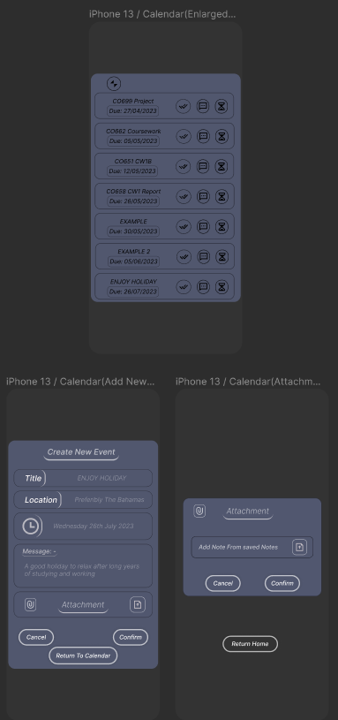These are the subpage that the Calendar app requires to function. It consists of components that was created for the screen to add functionality.

These sub screens weren’t hard to design since I hade some wireframes describing how I have already planned it to look. However, the designs didn’t fully align with the wireframes designed.

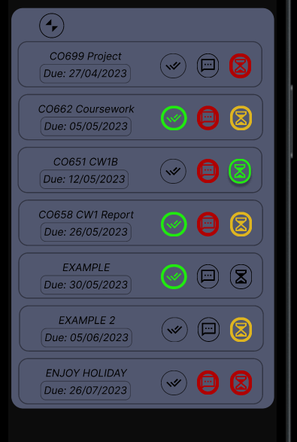The top screen would allow users to preview their scheduled events with the option to tick off to mark as completed add a note or change its priority.

The bottom Two screen are the ones that allow users to create new events for the calendar and add attachments to it from the saved notes in the app.

Figma had one issue which I didn’t find a solution for, and it was that when the project is running you couldn’t type in any boxes that were meant for users to fill. I made the text box interactive with the user but not for the users to fill with text.

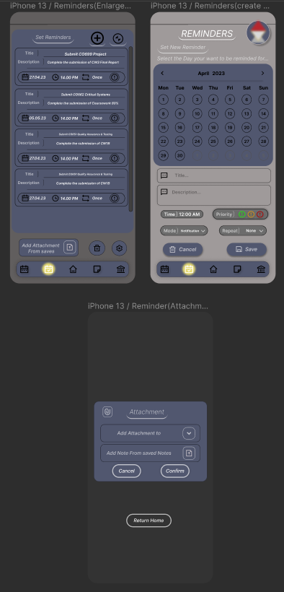Reminder: -

These are the sub screen for the Reminders feature with implemented functions. The first screen is an enlargement of the set reminders which are reactive and allows the user to select or mark as missed or completed.

The screen on the right shows the display for creating a new reminder and shows the customizations. The calendar allows the user to select their new reminders date and in doing so it will highlight the date with a yellow marker. In addition to a drop-down list for the “Mode”, “Repeat” and the priority.

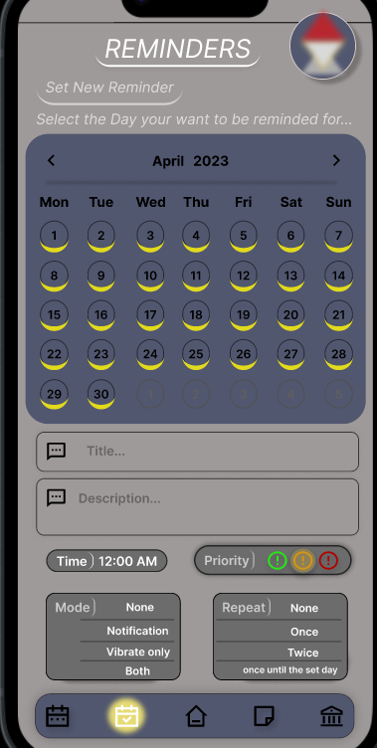**Examples**

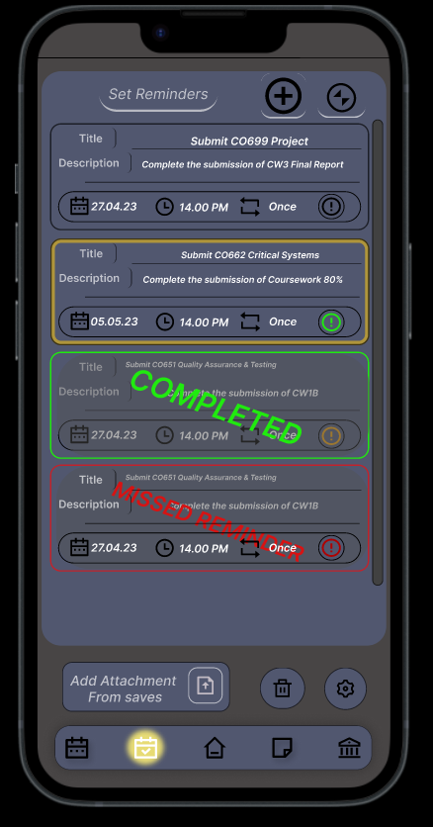

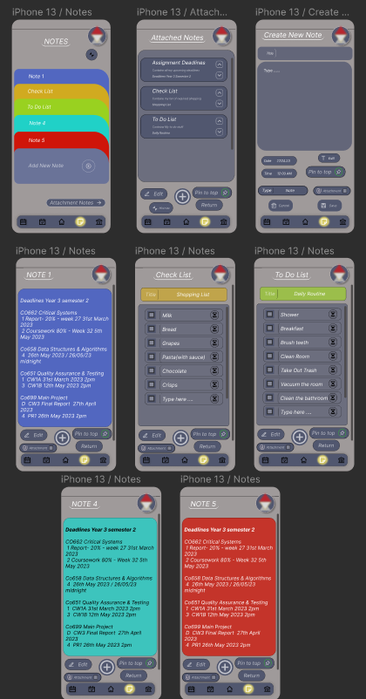Notes: -

These are the sub screens that make the notes feature have some functionality.

The attached notes screen displays the available notes that can be attached to other documents with the option to edit them or delete them.

The bottom 5 screens are the available options when creating a new note, they can select via drop down list. In addition to the option to pin it to the top (makes it visible in the mini widget in the home screen) or just create the note. Because I want to add the feature of attaching notes to events or reminders, I made a checkbox that would create a copy of the document that is able to be attached to other reminders or events.

**Example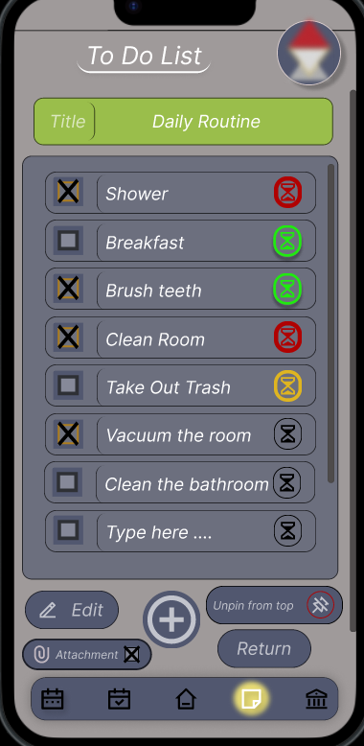s**

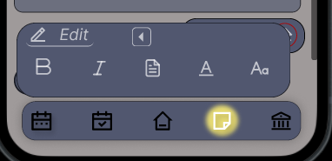

The last Step of stage 3 Is to create a home screen with a minimized feature of the already developed features (Calendar, Reminder, Notes). I was ahead of the plan here because I already designed the home screen and would only require implementing functions into it that synced up with the features already designed. A screenshot of a computer

These were other components that where necessary to be created for the functionality of some additional features to the home screen widgets.

Calendar Section: - Red outlined Box

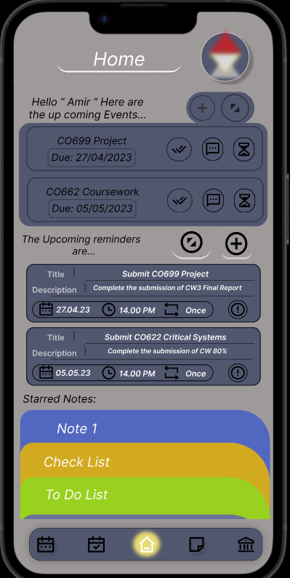Reminders Section: - Black Box

Notes & Budget Section is in the bottom section (scroll down to view)

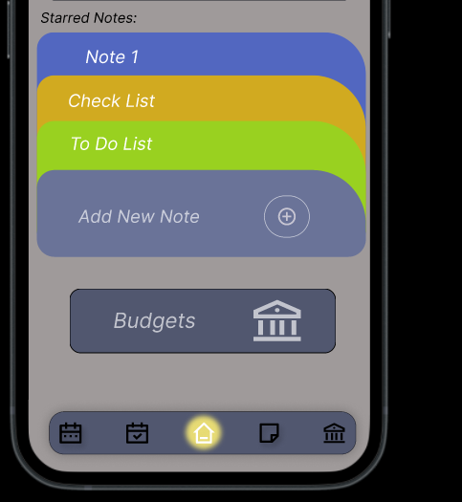

Stage 4 of the project plan was mainly dedicated for the Budgeting feature and adjustments to the interface of the functioning features. In addition to any issues that will be discovered while adjusting the features would require a quick fix to improve the project. Which meant to run the project and semi test the features developed to find any bugs or missed parts and fix them before moving into the next step of the development.

There weren’t many bugs but mostly small things I missed during the design/ implementation. The main issue was the interface alignment. I needed to align the design to the iPhone 13 screen shape and ensure that there isn’t any thing covered cause of misalignment.

After some time on testing the functions and the interface I continued to the next step of the project plan which was to start the budgeting Design/feature.

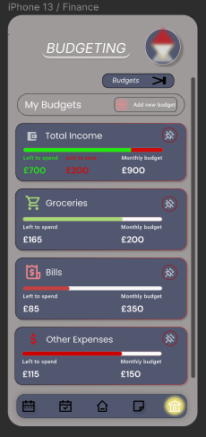

This was the 3rd design and my final choice that I went with. The previous designs didn’t feel like a budgeting app and overcomplicated the designing aspect of the app which would heavily impact the feature implementation stage.

The budgeting Main screen would display the set budgets into a widget lookalike and show an aesthetically pleasing design with enough information to understand the status of it.

A button to enlarge and preview all budgets set because the main screen would only show the pinned budgets. Underneath the enlargement button there would be the choice for the user to create a new budget.

The design of the budget screen was completed which meant to move to the next stage which was implement the functions into the budgeting screen.

The current and only function it has is the ability to pin and unpin a budget in the top right corner.

To implement functions to the budgeting feature it would require some sub screens and additional components to make it more interactive.

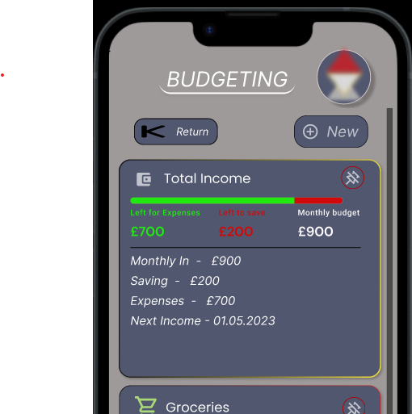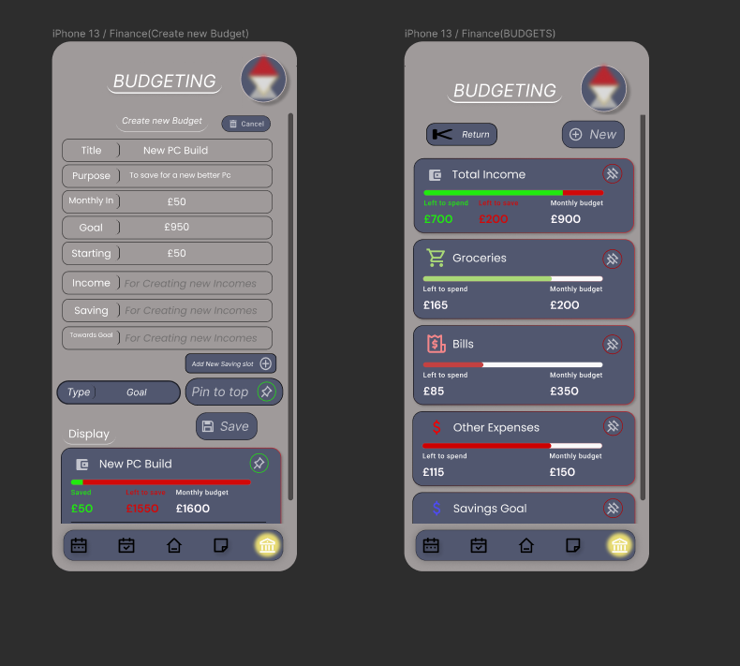

These are the designed sub screens for the extension of the budget feature. The left Screen is to allow the user to create a new budget and has the option to pin or select the budget type. The type of button is a drop-down list that has the choice to make a budget for saving, goal bills, expenses or create and income.

The screen on the right would be the results of pressing the enlargement button on the budgets main screen. It provides the option to create a new budget in addition to expanding the information on the individual budgets if pressed on.

This is how it would display when clicked on from its previous minimized form.

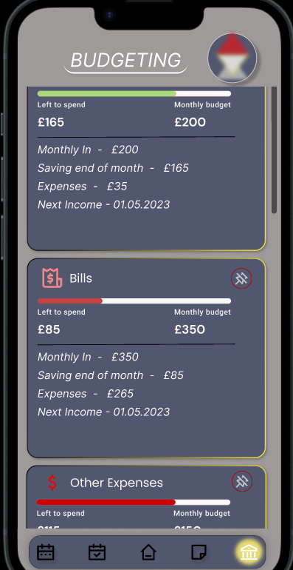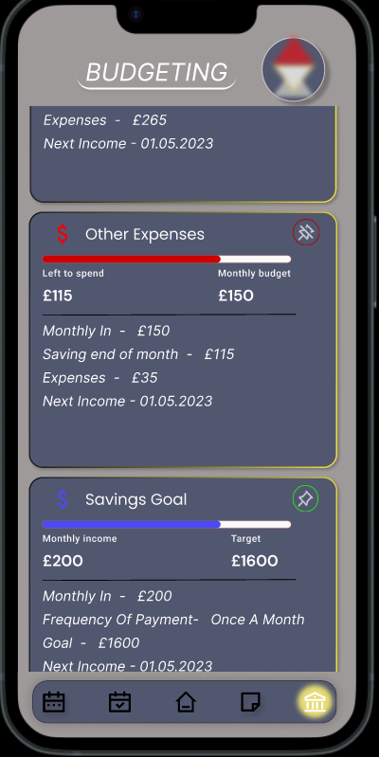

And to finalize the step is to test its functions and interface when thew project its running. Everything seemed to be fine and to complete this stage was to add a quick button to the budgeting screen which I just made a button for. I believe it wasn’t necessary with the navigation bar always available but wanted to add another path to the budgeting screen.



That would be the last step in stage 4 of the project plan and the next step would be to extensively test the app and the functions to try to identify any last issues before the submission. Stage 5 of the project plan would be displayed in the next section of this document.

## Testing (Approx. 850 Words):

In this section I will be testing the individual features in addition to a general overview of the prototype app and try to mark any missed issues and feedback on the features I prototyped. I have a couple questions which I will use to do some of the testing and while the testing I will try to document the information discovered. Because I have used the agile method some testing was being done throughout the development stages to try to get a better success feedback from the prototype. However, because figma limited the development when it didn’t allow the text boxes to be edited while in prototype mode it limited the functionality of the project. That is significant due to the project being a digital assistant that would require typing. But this would be the first prototype and my plan were to try to at least explain its purpose and concept to users and later with a much more developed project release it.

1. Does the Product look aesthetically please?
2. Does The Features meet the standard requirements?
3. What issues were discovered during testing the feature?
4. What changes would it need to improve?
5. Does the interface alight well with the created feature?

Login: -

The login screen worked smoothly but was limited due to not being able to type text into the text boxes. The interface for the login screens personally looked good and didn’t have any large issues. Security for this app wasn’t fully developed because I wanted to focus on the features and making them have as much function as possible.



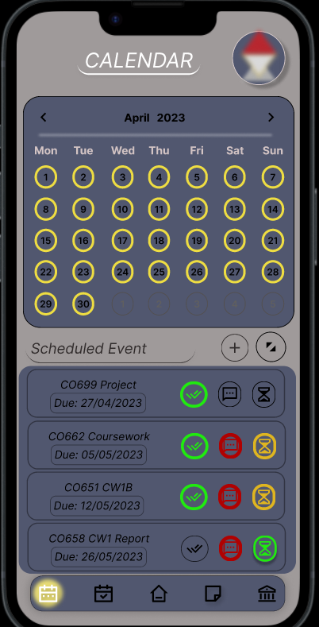

Calendar: -

Firstly, I will be testing the Calendar feature from functions to interface in addition to any design related issues. Testing the calendar feature and its concept is something I am proud of designing. The user interface seems to be working well and have smooth transitions. The calendar feature in my opinion would meet the requirements when its fully developed and not missing functionality. The functions did exactly as intend apart from the ability to edit boxes. I Didn’t find any major issues during the testing, but I discovered a slight colour change when the calendar is being interacted with which isn’t significant. The interface also aligns very well with the functions and the screen. Personally, I wouldn’t change anything apart from further improve on the functions for the next prototype. Both buttons to enlarge the events and add an event function as intended and lead to a sub screen that displays the next options for the user.

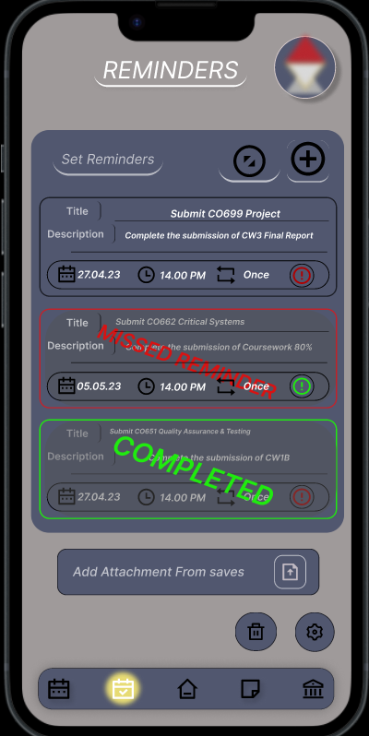

Reminders: -

The Reminders feature has a very clean and professional look to it. There was a button to add a reminder and enlarge the scheduled reminders and they functioned as intended by leading the user to the necessary sub screens. Clicking on a reminder allows the user to highlight the reminder to later mark ad complete or missed in addition to the priority button the bottom right corner of each reminder. Attachment button allows the user to attach a note to a reminder from the saves of the application. One thing I missed is the ability to edit the reminder after confirming which will be places under improvements to the reminders feature.

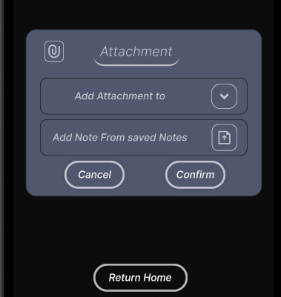

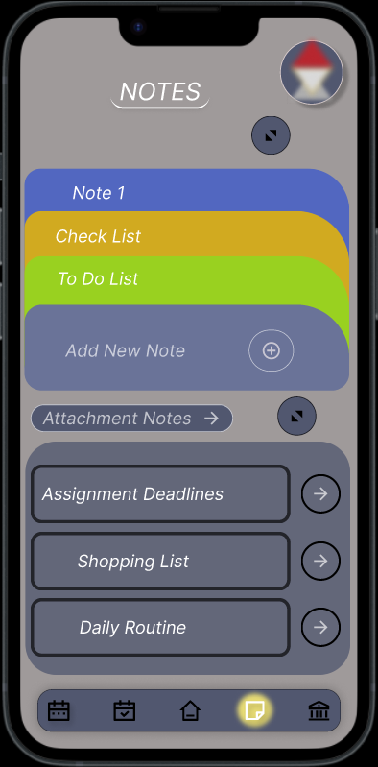Note: -

The Notes feature was very straightforward and obvious. The button that enlarges the notes functions and leads to a sub screen that has all the notes saved. The option to create a new note is presented in the middle of the screen and pressing it will lead the user to the option to create new note. The bottom part of the notes screen is the attachments section, and it contains the saved. Hovering over the attachment notes highlights their border in yellow to indicate selection and pressing the arrow next to the box will lead to the attached note.

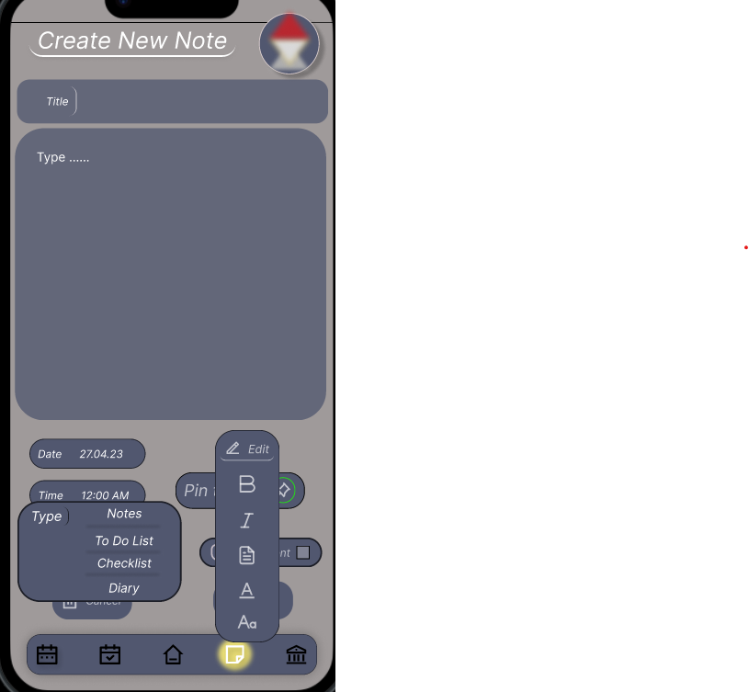

The edit button is the expanded version that is is supposed to provide a tool selection kit for the user to customize their note.

The type button is the expanded version which displays a drop down list for the user to select from to indicate the type of note it is.

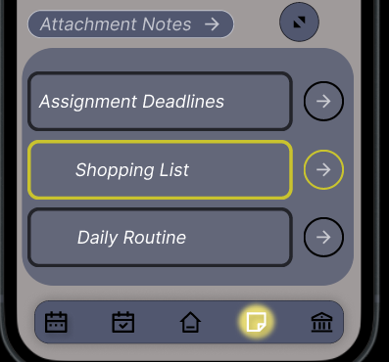

When hovering over the attachment buttons they highlight yellow to indicate selection and pressing the arrow will lead to the related note.

Budgeting: -

Testing the budgeting screen functions and the main functions of the main screen budgeting is to preview the set budgets and pin an unpin it from the main screen. The budgets button allows the user to preview all set budgets and function as intended. The add new budget will lead the user to the create budget screen which works as intended.

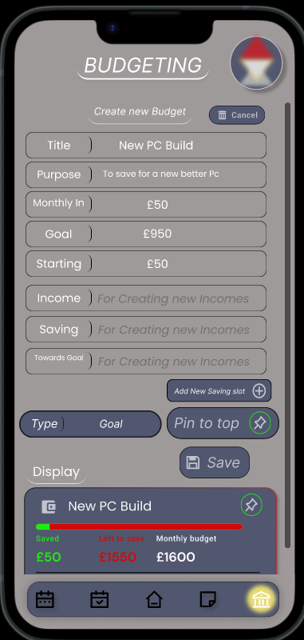

The Create Screen has various text boxes that currently don’t work but display the option for many choices and the option to create a custom one with a button.

The pining is like other features of the project and works the same. Pin to display it on the main screen. And a drop-down list to choose what kind of budget it is.

And right under the save button you can preview how it would look in the main screen and scroll down to see its enlarged state for the sub screen of budgeting.

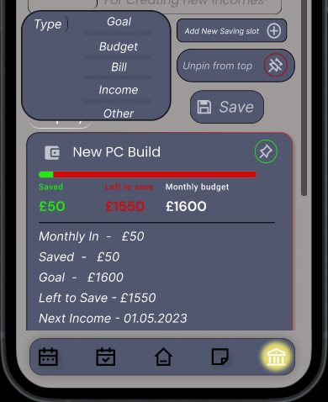

This would be the enlarged state. It also displays how the unpin button would look and the dropdown list for budget type selection.

The scroll functions as intended and has no interface issue that could affect the functions performance.

Lastly The enlarged screen that previews the budgets with the option to enlarge. The image on the left is how it firstly looks when opened. With the option to also create a new Budget and when clicked on the budget it enlarges to see the enlarged budget and it’s a scrollable screen.

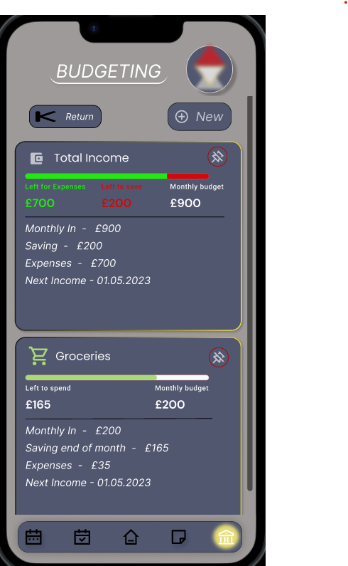

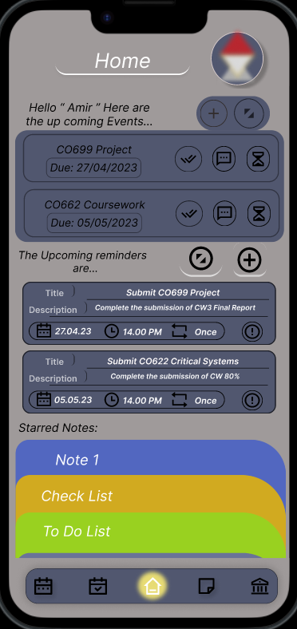Home Screen: -

The home screen was a combination of all the features where it had a small section of the top (pinned stuff by user) for a quick and easy access.

Most the buttons on the home screens lead to similar screens to their features and was just a smaller display of the most prioritized items that have been selected to be there by the user. And they all have similar features to their main feature pages. The interface was designed good and was very good fitted to form a main home screen.

The home screen tested to be functional and works as its intended to work with no delay or issue. The only issue I have discovered was that the navigation bar sometimes resets when you double click on a screen to go to.

1. **Calendar: Schedule events + have an attached note from notes feature.**

This was the first requirement and I believe my project has achieved this requirement.

1. **Reminders: create more specified reminder (specific time/Day) in addition to creating a daily reminder of a checklist using notes attachments.**

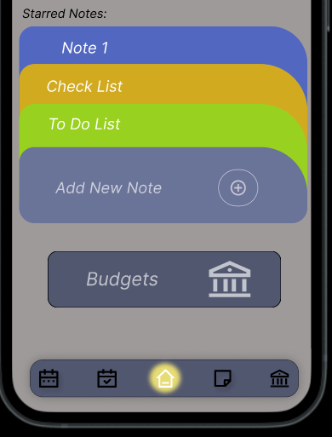The second requirement has also been achieved because it has been implemented into the reminders and the notes section of the app.

1. **Notes: Allows to write notes + create checklists, attachable to reminders and calendar.**

This Requirement was also included in the project, and I believe has been achieved to an extent.

1. **Budgeting: provides the ability and tool to financial management and have an overview of your financial savings.**

I believe this requirement was difficult to achieve because financial management would require a lot more security needs. My project currently has no security because the focus was the features and their functions. In the app you can preview a budget to later implement your budget into your banking account.

1. **Security: adding login & password with the possibility of additional authentication required for new devices. (Unlocks app with FaceID or a set 4-digit code)**

Unfortunately, I couldn’t code or implement heavy security apart from designing the login interface that can’t check for an input due to figmas limitations.

## Implementation (Approx. 850 Words):

The Purpose of my project is to provide organizational assistance. For example, as students some may struggle to keep track of their deadlines, home chores, work, and general help with day-to-day tasks. My hope is that my app provides a platform for someone to use and rely on to assist them with their struggles. My Project was designed with the purpose of aiding the user with their day-to-day tasks that they struggle to keep organized from a simple wake up routine to completing your assignments that have a deadline. In the current world we rely on technology significantly and most people always have a smart device with them for multiple reasons from social media to getting to work using a bus times app to get to work. My project would help aid the users by helping them organize and list their priorities to be as efficient as possible when needed. My project isn’t something that would require groups together but is for the user to input their information in a save space where they could have an overview of what their next steps are.

Currently because my prototype is limited and can’t input any text it wasn’t able to be tested by users in a day-to-day situation. However, this is just because the prototype was developed to test the concept of my idea and combination of features which I think was very successful and the next prototype will be a much better prototype due to the experience I was able to gain while working on this prototype. The main issue was that there wasn’t the ability to input text which was a significant issue and will definitely be solved in the next prototype, but with the limited experience of mobile app development I wasn’t able to improve the quality of the project but allow it to have other reactive functions such as having a highlighted area when the user hovers over something or other components used to make the prototype. Throughout the development of the project my experience with using figma increased but wasn’t up to a high standard to develop an advanced prototype but more of a semi functional prototype.

Improvements: -

I believe there is a lot that can be improved in this current prototype. When I started this project, I had no experience in mobile app development and even now my experience is limited, however the next prototype will be significantly better because of the knowledge I have gained during this development process. During the implementation of the note’s features, I wanted to make the saved notes scrollable but couldn’t do so because I didn’t understand how but I think that will be easily done in the next prototype. This is to avoid having to return to main note screen to switch to another note.

## Conclusions (Approx. 300 Words):

To summarize this project in my opinion was a success. My mobile app development experience was little to non, but I understood the development process from previous projects. This project had a couple of requirements which have been meet to an extent because of my lack of experience. My choice of using figma as one of my development tools was very restrictive but due to my experience my choices want many, however I was able to use figma and design and implement certain functionality to display the concept of my project idea and achieve the requirement to an extent.

Starting with the first requirement which was to have a calendar to schedule events. My prototype has a feature which allows the user to create an event and see their scheduled ones with the addition of a calendar widget that would display if the day would be busy or not by a coloured indicator around the day number. The next requirement would be the ability to schedule a reminder and have attachments to them. My reminders feature does meet this requirement but If I would redo this requirement, I believe I could improve its functionality much further because currently I think it’s too simple and contains few functions. The notes feature isn’t a unique feature and is the 3rd requirement. Notes currently does the same as every other note app with the ability to attach a note to a reminder or event. The last feature that is also a requirement is the budgeting feature which also meets the requirement to an extent. I believe with the limitation of not being able to input text the budget feature meets the requirement and in the next prototype will have a better interface and functions. The last requirement was to have security by having a login and password that is accessible by FaceID or password of the user’s choice. Unfortunately, the focus of this prototype was to have functions in the required features and with my limited experience I couldn’t meet the login requirement but was able to make an interactive login screen without any security. I believe this project has meet most of their requirements with the limitations set by my experience and figmas development tools but will be exceeded in the next prototype. The projects aim was achieved, and I believe that my app displays the concept of my project greatly and contains some functions that are very self-explanatory and an essential to the requirements. The objectives were a good base to start of from and the project plan was very similar but had some changed that I believed was necessary during the development. For Example, the objectives planned to complete each feature in the order of design then implementing features and then continuing with the rest in the same manner, where during the project plan I decided to design all then continue the implementations.

To summarize with my limited experience in app prototyping my choices was restricted, however I believe the outcome of the project prototype is something I would consider a success. My previous experience of the development process assisted me significantly during this project. The first prototype was able to display the concept of my idea and improve my development experience. This project has taught me to fully create a mobile app and prototype it to further continue the process.

## Recommendations for Further Work (Approx. 200 Words):

In this section I will discuss what I could do next to further improve upon my project. The first prototype was just to see if the concept of a combined set of features function having together which ended up looking good and functioning well together, but my restricted tools didn’t allow for certain features. Which leads me to the main issue of this project which was that there couldn’t be a text input for any of the text boxes to improve the preview of the app. This was a significant issue that restricted the project a lot but was an expected risk when working on new project with no experience.

## Software Artefact Download

GitHub Link :- All of module CO699 Is in the GitHub apart from the Artifact recording.

<https://github.com/Amir94Mohamed/Main-Project-CO699>

This is the file for the exported Figma Screens/Components. Available on GitHub too!!!

This is a link to a google drive where it contains a display recording of my prototype project(Artifact)

<https://drive.google.com/file/d/1enMJhQsZ0lsuS_f1EnpBQauFrJd30IJ1/view?usp=share_link>

## Glossary (Unlimited Words):

Database: - According to an article by Lutkevich, B and Hughes, A (2021) “What is database?” it mentions that Databases are information storage the is easy accessed and managed by a computer used to store information given to it by users as a by-product of a service being provided.

Ethical Consideration: - A website by Bhandari, P. (2022) “Ethical considerations in research” mentions all the reasons why it is important to developing software. To summarize, Ethics is important to ensure the safety of the client’s information. It continues to mention that the (IRB) Institutional Review Board will require a research proposal for the developers to get approval to continue the development of their software.

## References (Unlimited Words):

Introduction: -

Ilic, A. (2016) Problems keeping up? 10 apps to make you highly organized, Lifehack. Available at: https://www.lifehack.org/463502/problems-keeping-up-10-apps-to-make-you-highly-organized (Accessed: December 21, 2022).

Herbert, J. (2021) 5 surprising benefits of being organized - selecthealth.org, 5 Surprising Benefits of Being Organized. Available at: https://selecthealth.org/blog/2021/01/5-surprising-benefits-of-being-organized (Accessed: December 21, 2022).

IreneIt’s high time to get down to the most popular programming languages for mobile app development. Do these app development languages differ from those…, (Author not found) (2022) Topmost popular programming languages for mobile app development, Fireart Studio. Available at: https://fireart.studio/blog/top-most-popular-programming-languages-for-mobile-app-development/ (Accessed: October 28, 2022).

Background: -

Pete, M.S. (2022) Emma App Review: Money management made easy?, Household Money Saving. Available at: https://www.householdmoneysaving.com/emma-app-review/ (Accessed: October 29, 2022).

Smith, K. (2020) 8 free personal assistant apps, The Muse. The Muse. Available at: https://www.themuse.com/advice/8-free-apps-that-double-as-personal-assistants (Accessed: November 3, 2022).

Rationale :-

Kourmentza, E. (2022) Software engineer job description, Recruiting Resources: How to Recruit and Hire Better. Available at: https://resources.workable.com/software-engineer-job-description (Accessed: November 4, 2022).

Kalinin, K. (2022) How to create a personal finance app for Budget Planning in 2022, Topflight. Available at: https://topflightapps.com/ideas/how-to-build-a-budget-app-for-personal-finances/#4 (Accessed: January 7, 2023).

Abstract: -

Gavriluk, V(Feb 22, 2023)10 Figma Tips and tricks for designers Available at: <https://arounda.agency/blog/10-figma-tips-and-tricks-for-designers-in-2023> (Accessed: April 23, 2023)

Ethical considerations: -

Literature Survey: -

Firenze, A. (2022) 14 Essential App Development Team skills you must have, Ascendle. Available at: https://ascendle.com/ideas/14-skills-your-app-development-team-must-have/ (Accessed: November 5, 2022).

Ching, C. (2021) How to make an app in 2021 from start to finish (10 steps), CodeWithChris. Available at: https://codewithchris.com/how-to-make-iphone-apps-with-no-programming (Accessed: November 9, 2022).

Stevens, G. (2022) 6 best calendar app features to help you manage your business better, Zoho Blog. Available at: https://www.zoho.com/blog/calendar/best-calendar-app-features.html (Accessed: November 9, 2022).

Shibli, A. (2022) 15 best organization apps for life & work in 2022, 15 Best Organization Apps for Life & Work in 2022 | Friday.app. Available at: https://friday.app/p/organization-apps (Accessed: November 6, 2022).

Pete, M.S. (2022) Emma App Review: Money management made easy?, Household Money Saving. Available at: https://www.householdmoneysaving.com/emma-app-review/ (Accessed: November 5, 2022).

Altexsoft (2019) Agile Project Management: Best practices and methodologies, AltexSoft. AltexSoft. Available at: https://www.altexsoft.com/whitepapers/agile-project-management-best-practices-and-methodologies/ (Accessed: January 10, 2023).

Methodology: -

Monday Work Management : - [www.Monday.com](http://www.Monday.com) ( <https://a94m.monday.com> ) Unfortunately I don’t think you could access it(Images in Methodology section)

Figma Desgining/ Development Tool: - [www.Figma.com](http://www.Figma.com)

<https://www.figma.com/file/OE4gwdmcVe1z2xwPnR91OZ/Personal-Assistant?node-id=0-1&t=zqSMMmT8mRKqlPy7-0> ( You Could Request to view this file if you have an account, I just have to accept Email Me if I needed to accept)

Glossary: -

Lutkevich, B. and Hughes, A. (2021) What is a database? definition from searchdatamanagement, SearchDataManagement. TechTarget. Available at: https://www.techtarget.com/searchdatamanagement/definition/database (Accessed: November 4, 2022).

Bhandari, P. (2022) Ethical considerations in research: Types & examples, Scribbr. Available at: https://www.scribbr.co.uk/research-methods/ethical-considerations/ (Accessed: November 4, 2022).

Methodologies: -

Altexsoft (2019) Agile Project Management: Best practices and methodologies, AltexSoft. AltexSoft. Available at: https://www.altexsoft.com/whitepapers/agile-project-management-best-practices-and-methodologies/ (Accessed: January 10, 2023).

Unknown (2021) The benefits & Advantages of Agile: Wrike agile guide, Wrike. Available at: https://www.wrike.com/agile-guide/benefits-of-agile/ (Accessed: January 10, 2023).

Welch, S. (2021) The 5 best C++ IDES, Udacity. Available at: https://www.udacity.com/blog/2020/05/best-c-ides.html (Accessed: January 10, 2023).

## Bibliography (Unlimited Words):

Your text here.

## Appendix A: Project Plan (Unlimited Words):

This section will provide a step-by-step plan to develop our software idea. Each step will take approximately 2-3 days unless it has multiple sections which would increase its work requirement which may increase the risk of delays.

1. Use the researched gathered to double check the language to code the software idea in and the correct tool is selected.
2. Start creating the template of the application screens.
3. Use template to create the screens for the individual features planned to be and assign them with the intended feature to be added.
4. Create screen for Calendar feature.
5. Create screen for Reminder’s feature.
6. Create screen for Checklist feature.
7. Create screen for Budgeting feature.
8. Create Account Screen
9. Create functioning user interface with a navigation bar that has linked all screens together and functions.
10. Check with objectives and ensure project is progressing according to the objectives.
11. Implementing the features stage was split into sections.
12. Code Calendar screen
13. Code Reminder screen
14. Code Checklists screen
15. Code Budgeting screen
16. Code Account screen
17. Implement the coded sections into the assigned screen.
18. Double check that the feature’s function and are good with the created interface.
19. Make final adjustments to the features and interface to ensure they work in sync an as intended.
20. Attempt to build the first prototype and test it by comparing it to the requirements.
21. Final checks:
22. Check the features work (A, B, C, D, E)
23. Ensure the interface functions as intended.
24. Prototype functions as intended.

## Appendix B: Ethics Checklist (Unlimited Words):

A checklist should be completed for every research project. This is used to identify whether a full application for ethics approval needs to be submitted to the University Ethics Panel or one of its sub-committees. Further guidance can be found on the Ethics Blackboard shell.

|  |  |
| --- | --- |
| 1 Applicant details | |
| Name of Lead Researcher (applicant): | Amir Mohamed |

|  |
| --- |
| 2 Project details |
| Project title: A Digital assistant developed using tools such as visual studio that can contain all your Daily Tasks, Routines, Appointments, Checklists, Financial Budgeting to assist users with their daily struggles of organization and increase their work rate by ensuring an organized app that can be used like an assistant for the user’s organizational needs. |
| Please provide a brief description of the project:  The purpose of my project is to provide an application to users that can store their Important appointments, tasks, deadlines, and others in the app. In addition to being reminded about important task users needed to be reminded about, and a feature that is similar is the notes/checklists. Lastly the budgeting feature where users can manage their finances. |

|  |  |  |  |
| --- | --- | --- | --- |
| 3 Research checklist  Please answer each question by checking the appropriate box: | | | |
| Research that may need to be reviewed by an NHS Research Ethics Committee or another external Ethics Committee | | YES | NO |
| 1 | Will the study involve recruitment of patients or staff through the NHS or Social Care, or the use of NHS data or premises and/or equipment? |  |  |
| 2 | Does the study involve participants age 16 or over who are unable to give informed consent (e.g. people with learning disabilities: see Mental Capacity Act 2005)? NHS |  |  |
| 3 | Will tissue samples (including blood) be obtained from participants? |  |  |
| If you have answered ‘Yes’ to questions 1, 2 or 3 please refer to <http://www.hra.nhs.uk/> for guidance. If external ethical approval is not needed, University ethical approval will still be required. | | | |
| Research participants | | YES | NO |
| 4 | Does the study involve students within the University? |  |  |
| 5 | Does the study involve employees of the University? |  |  |
| 6 | Does the research involve potentially vulnerable groups: children, those with cognitive impairment, or those in unequal relationships? (eg your own students) |  |  |
| 7 | Does the research involve members of the public or people worked with in a professional capacity? |  |  |
| 8 | Will the study require the co-operation of a ‘gatekeeper’ for initial access to the groups or individuals to be recruited and/or to give permission for initial contact? (e.g. children, students, members of self-help group, residents of nursing home, employees). |  |  |
|  | | | |
| Research methods | | YES | NO |
| 9 | Will it be necessary for participants to take part in the study without their knowledge and consent at the time? (e.g. covert observation of people in non-public places) |  |  |
| 10 | Will financial inducements (other than reasonable expenses and compensation for time) be offered to participants? |  |  |
| 11 | Will the study involve discussion of sensitive topics or illegal activity (e.g. sexual activity, drug use)? |  |  |
| 12 | Are drugs, placebos or other substances (e.g. food substances, vitamins) to be administered to the study participants or will the study involve invasive, intrusive or potentially harmful procedures of any kind? |  |  |
| 13 | Is physical pain or more than mild discomfort likely to result from the study? |  |  |
| 14 | Could the study induce psychological stress or anxiety or cause harm or negative consequences beyond the risks encountered in normal life? |  |  |
| 15 | Will the study involve prolonged or repetitive testing? |  |  |
| 16 | Is there a possibility that the safety of the researcher may be in question? |  |  |
| 17 | Will any of the research take place outside the UK (excluding on-line surveys)? |  |  |
|  | | | |
| Data and confidentiality | |  |  |
| 18 | Will the research involve administrative or secure data that requires permission from the appropriate authorities before use? |  |  |
| 19 | Will the research involve visual/vocal methods where respondents may be identified? |  |  |
| 20 | Will research involve the sharing of data or confidential information beyond the initial consent given? |  |  |
| 21 | Will the research involve security-sensitive data? (eg commissioned by the military or under an EU security call; involve the acquisition of security clearances; concerns terrorist or extremist groups). |  |  |

If any item is checked “YES” you will need to seek advice from your supervisor / course leader regarding the appropriate sub-committee for ethical approval.

4. Declarations

I have read and will abide by the University’s *Ethics Policy*.

I have read and will abide by the University’s *Code Research Practice*.

I am aware of, and will abide by the ethical guidelines published by the relevant subject and/or professional associations most appropriate to my topic.

The responses given above are an accurate and true reflection of the nature of my research project.

Applicant:

|  |
| --- |
| Name (please print): Amir Mohamed |
| Signed: AMIR |
| Date: 25/04/2023 |

Project supervisor / Line manager

I confirm that the above details are accurate, the proposed methods are appropriate, ethical concerns have been considered and that time and resources are available for the research to take place.

|  |
| --- |
| Name (please print): Amir Mohamed |
| Signed: AMIR |
| Date: 25/04/2023 |

Note: Electronic approval by above signatories is acceptable

## Appendix C: Participant Consent Form (Unlimited Words):

|  |
| --- |
|  |

**Notes**

1. Black text forms the standard content of a consent form
2. **[**Insert specific information in the highlighted square brackets**]**
3. Text notes in the grey boxes provide guidance only and are to be removed in the final consent form
4. Blue text indicates optional statements to add
5. This form must be accompanied by a participant information sheet.

Informed Consent for [name of study]

|  |  |
| --- | --- |
| **Please tick the appropriate boxes** |  |
| 1. **Taking part in the study** |  |
| I have read and understood the study information dated **[**DD/MM/YYYY**]**, or it has been read to me. I have been able to ask questions about the study and my questions have been answered to my satisfaction. | 🞏 |
| I consent voluntarily to be a participant in this study and understand that I can refuse to answer questions and I can withdraw from the study at any time, without having to give a reason. I can withdraw my data up until [DD/MM/YYYY] which is the final date before data is analysed. | 🞏 |
| I understand that taking part in the study involves **[**…………………………………………**]**.  Describe in a few words how information is captured, using the same terms as you used in the information sheet, for example: an audio-recorded interview, a video-recorded focus group, a survey questionnaire completed, an experiment, etc.].  For interviews, focus groups and observations, specify how the information is recorded (audio, video, written notes).  For questionnaires, specify whether participant or researcher completes the form.  For audio or video recordings, indicate if these will be transcribed as text, and whether the recording will be destroyed.  If there is a potential risk of participating in the study, then provide an additional statement:  I understand that taking part in the study has **[**……………………………….**]** as potential risk. | 🞏  🞏 |
| 1. **COVID-19 safety** |  |
| I confirm that I have not had any of the following symptoms in the last 14 days: fever, dry, persistent cough or a loss of sense of taste or smell. | 🞏 |
| I confirm that I am not in the clinically extremely vulnerable category and therefore advised to shield at home by the government. | 🞏 |
| I confirm that to the best of my knowledge, I have not been in close contact with anyone with confirmed COVID-19 in the last 14 days. | 🞏 |
| I confirm I am aware of the requirement for social distancing whenever possible, hand decontamination, and use of face-covering during the research and that the researcher may also use further PPE. | 🞏 |
| I confirm I have been told about the cleaning of the venue and equipment before/after my attendance. | 🞏 |
| It has been confirmed by the researcher that they have not shown any of the above-named symptoms of COVID-19 nor, to the best of their knowledge, been in close contact with anyone with confirmed COVID-19 in the last 14 days. | 🞏 |
| 1. **Use of the information in the study** |  |
| I understand that information I provide will be used for **[**………………………………….……**]**.  List the planned outputs, e.g. reports, publications, website, video channel etc., using the same terms as you used in the study information sheet. | 🞏 |
| I understand that personal information collected about me that can identify me, such as my name or where I live, will not be shared beyond the study team.  Under some circumstances, access to this information should be restricted to the researcher only. | 🞏 |
| I consent to the processing of my personal information for the purposes of this research study. I understand that such information will be treated as strictly confidential and handled in accordance with current UK Data Protection legislation. | 🞏 |
| If you want to use quotes in research outputs, add: I agree that my information can be quoted in research outputs. | 🞏 |
| If you want to use named quotes, add: I agree that my real name can be used for quotes. | 🞏 |
| If written information is provided by the participant (e.g. diary), add: I agree to joint copyright of the **[**specify the data**]** to **[**name of researcher**]**. | 🞏 |
| 1. **Future use and reuse of the information by others** |  |
| I give permission for the **[**specify the data**]** that I provide to be used for future research and learning.  Specify in which form the data will be stored, e.g. de-identified (anonymised) transcripts, audio recording, survey database, etc.. If needed, repeat the statement for each form of data you plan to store.  Specify whether stored data will be de-identified (anonymised), and how. Make sure to describe this in detail in the information sheet.  Specify whether use or access restrictions will apply to the data in future, e.g. exclude commercial use, apply safeguarded access. | 🞏 |
| 1. **Signatures** |  |
| _________________ ____________________ ___________  Name of participant [IN CAPITALS] Signature Date |  |
| For participants unable to sign their name, mark the box instead of signing  I have witnessed the accurate reading of the consent form with the potential participant and the individual has had the opportunity to ask questions. I confirm that the individual has given consent freely.  ___________ _________ __________________ _________ __  Name of witness [IN CAPITALS] Signature Date |  |
| I have accurately read out the information sheet to the potential participant and, to the best of my ability, ensured that the participant understands to what they are freely consenting.  __________________ ________________ _ ______ __ Name of researcher [IN CAPITALS] Signature Date |  |
| 1. **Study contact details for further information**   **[**Name, phone number, email address**]** |  |

**One copy to be kept by the participant, one to be kept by the researcher**

## Other Appendixes (D, E, F etc. as required) (Unlimited Words):